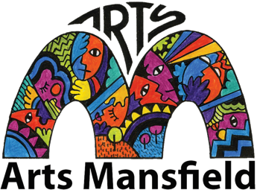

Arts Mansfield Inc. Committee nomination form

Please send to our email so that we receive it by January 20 2024
Email: artscouncilmansfield@gmail.com

Nomination for committee position, Arts Council of Mansfield Inc.

I _______________________________________________________ (Name)

Of, _______________________________________________________ (Address)

Agree to nominate for the position of:

_______________________________________________________
(President, Vice President, Secretary, Treasurer, Membership Secretary, Social Media/Website/Marketing Support Officer, Fundraising & Sponsorship, Event liasion), of the Arts Council of Mansfield Incorporated for the year of 2024

Signature of Nominee Date

Proposed by

I, ____________________________________________ a member of the Arts Mansfield Incorporated nominate the applicant, who is personally known to me, for the above role of the Association.

______________________________ _____________________________
Signature of Proposer Date

Seconded by

I, ____________________________________________, a member of the
Arts Mansfield Incorporated second the nomination of the applicant, who is personally know to me, for the above role of the Association.

______________________________ _____________________________
Signature of Seconder Date

