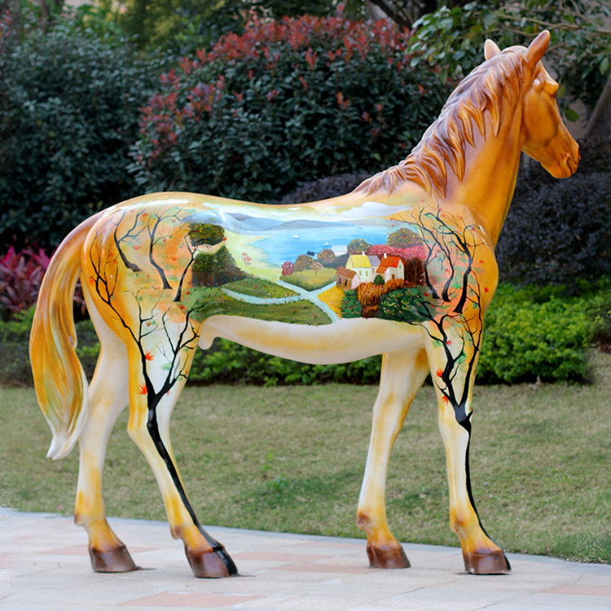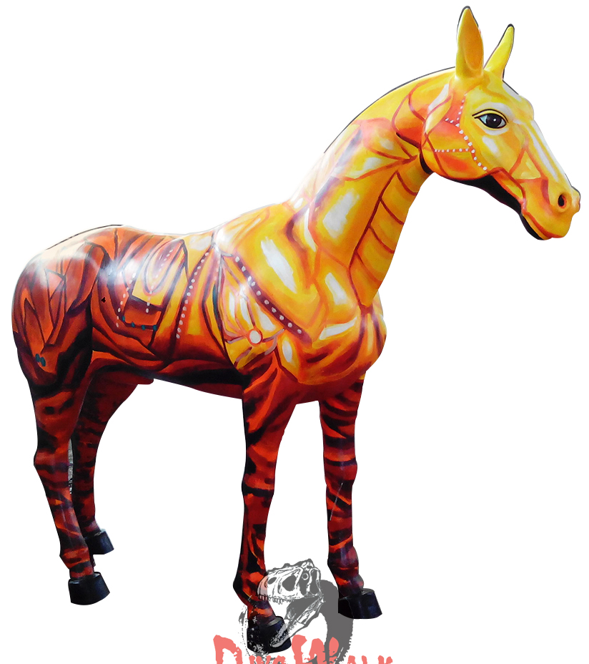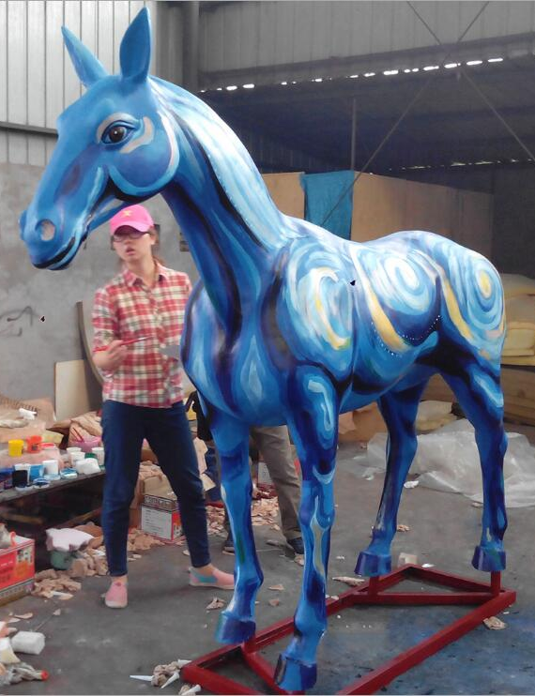
EXPRESSIONS OF INTEREST
TO PAINT A LIFE-SIZED HORSE
AS PART OF MANSFIELD RACE CLUB’S 2022 ART PROJECT

ARTS MANSFIELD IS INVITING ARTISTS TO SUBMIT AN EXPRESSION OF INTEREST BY CREATING A CONCEPT DESIGN FOR THIS PROJECT

Summit Outfitters has offered a life-sized fibre glass horse to be used as a
promotional tool for Mansfield Race Club’s 2022 events.
The first of these is a Trivia Night on Thursday October 13.
There is no theme but the successful applicant should use appropriate imagery
Materials and mediums will be the choice if the artist
Work space available at Mansfield Artists Collective Studios in Crosby’s Lane
The Mansfield Race Club will organise transport of the horse.
Summit Outfitters and Arts Mansfield Logos will be applied to the horse
prior to the artistic decoration.
The successful applicant will be financially supported by Arts Mansfield
up to the amount of $1500.
This includes remuneration, materials and equipment, hire of studio space.
The artist will also gain promotion via social media platforms.
Name of Artist
Address
Mobile Number
Email Address
Theme
Medium of artwork
Require Studio Space?
Please include images for your concept design and email to
artscouncilmansfield@gmail.com Or mail, with this EOI form to
Arts Mansfield, PO Box 32, Mansfield by September 16, 2022
Enquiries to Felicity Hayward - 0418790109


